**FOREVER IS A LIE**

**-Akshita Gupta,BVCOE**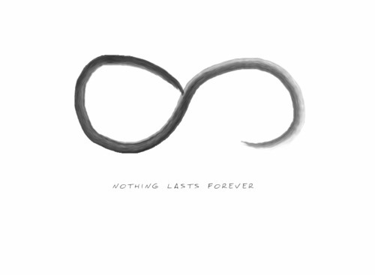

"A single rose can be my garden and a single friend, my world." Sometimes a single person is capable of making you happy, when a crowd of people fail to do so. Unlike the rest of the world, that person accepts you as you are, with neither any complaints nor demands.

This poem is about the importance of that one single person in your life, with whom you can share any kind of relationship. But sometimes this remarkable relationship is scarred by certain forces that make it hollow and meaningless.

This is about all those who have gone through such a situation and despite having a desire to reconnect, are not able to do so.

As the rays of the sun bring the sunflower alive,   
Your very presence gave me life.   
Those days when you supported me are gone, Sans you; I do nothing but moan.

Remember the fun we had   
With all reasons to smile and nothing to be sad.   
But now everything is in vain,   
Because you say it was all insane.

Life has gotten harder, with tears blinding my eyes,   
Why even in your presence, our memories of togetherness arise? You are not the same as you used to be,   
How do I get you back, when you are always trying to escape me?

I cannot see the warmth in your eyes that I have known,   
You are not here and I am left all alone.   
Never will I be able to share such a bond again;   
I'll miss you even though you gave me so much pain.

Now when all is gone, never to come back,   
Emotions is one thing that I lack.   
My tears have dried up and my heart with a deep sigh, Has accepted that "forever is a lie".

